**Assignment: Real-Life Industry Use Cases of Basic Linux Commands**

**Task 1: Basic Linux Commands in a Real-World**

**1. Check current logged-in user and system information**

Whoami  
uname -a

**Output:**



**2. Navigate to the /projects directory and list contents**

cd /projects  
ls -l

**Output:**

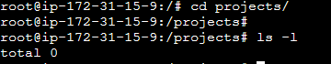

**3. Create a new project directory and verify it**

mkdir project  
ls -l

**Output:**

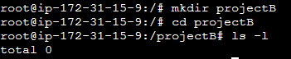

**4. Create a sample file inside projectB**

touch projectB/README.txt

echo "Welcome to Project B" > projectB/README.txt

cat projectB/README.txt

**Output:**  
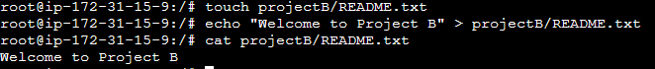

**Task 2: User and Group Permissions Management  
1. Create a new user john and add him to the developers group**

sudo groupadd developers  
sudo useradd -m -G developers john  
sudo passwd john

**Output:  
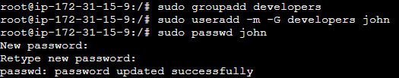**

**2. Verify user and group**

id john

**Output:  
**

**2. Verify user and group**

id john

**Output:  
**

**3. Change group ownership of projectB to developers**

sudo chown :developers /projects/project

**Output:  
**

**4. Modify permissions so that only the group can write**

sudo chmod 770 /projects/project  
ls -ld /projects/projectB

**Output:  
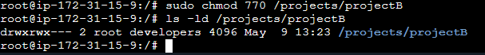**

**Task 3: Changing File Ownership  
1. Change ownership of projectB to john**

sudo chown john:developers /projects/project

**Output:  
**

**2. Verify the ownership chang**

ls -ld /projects/projectB

**Output:  
**

**Task 4: System-Level Monitoring Commands**

**1. Check system uptime**

Uptime

**Output:**



**2. Monitor disk usage**

df -h

**Output:**

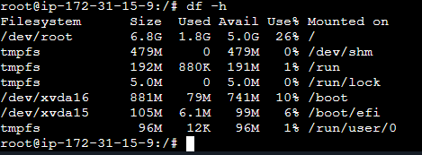

**3. Check memory usage**

free -m

**Output:**



**4. Monitor running processes**

ps aux --sort=-%mem | head -5

**Output:**  
